BAGOEXPRESS: MODERNIZING LOCAL TRANSPORT AND DELIVERY SERVICE SYSTEM

Abstract

As students from the Bago City Negros Occidental, we developed BagoExpress to improve the efficiency and reliability of local transport and delivery services. The system was built using the Agile Scrum methodology, allowing for iterative development and collaboration with key stakeholders such as tricycle operators, passengers, and the business community. BagoExpress includes features like AI-powered route optimization, driver tracking, and cashless payments, providing users with enhanced security and convenience. The system aims to modernize traditional transport services by introducing a cashless, technology-driven platform that addresses the evolving needs of the local community.

Keywords: Agile Scrum, AI-powered routing, driver tracking, cashless payment

**Introduction**

Where the pulse of Bago City meets the future of transport and delivery. Picture a system that makes getting around town a breeze, ensuring your packages arrive swiftly and securely. "BagoExpress" is your ticket to a smoother journey and efficient deliveries, designed with you in mind. Whether you're hopping on for a ride across town or sending an urgent package, "BagoExpress" is your reliable partner in navigating Bago's vibrant streets. 1. The system has a capability to monitor passengers’ location through GPS tracker to ensure passengers safety. 2. The system is able to allow users to share real-time locations with trusted contacts during nighttime rides, ensuring safer journeys. 3. The system is able to integrate with AI-driven "Smart Routing" suggest the most efficient and shortest routes reducing travel times and fuel consumption. 4. The system is able to ensure tricycle drivers follow to fixed fare rates. 5. The system has the capability to offer user a recommendation for travel tours to nearby attraction suggestions based on their preferences. 6. The system is able to integrate Gcash payment for secure and convenient online transactions.

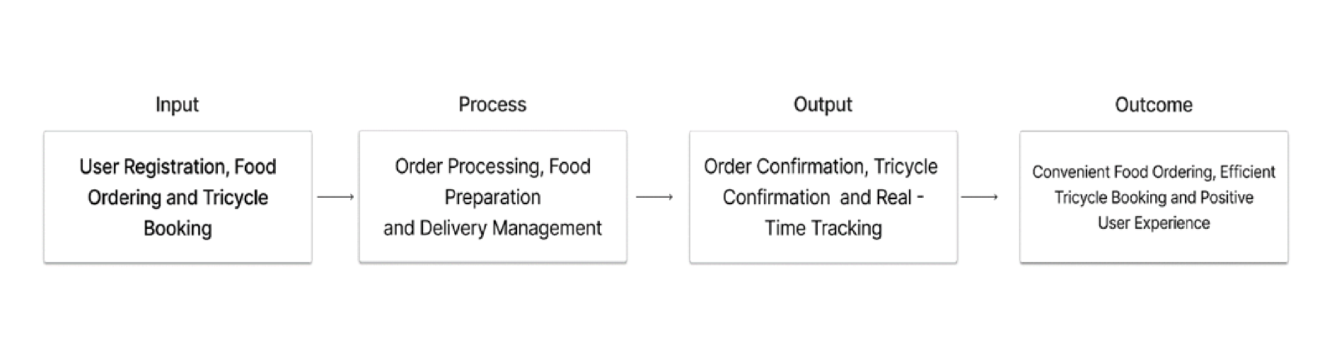**Conceptual Framework**

Figure 1. Conceptual Framework

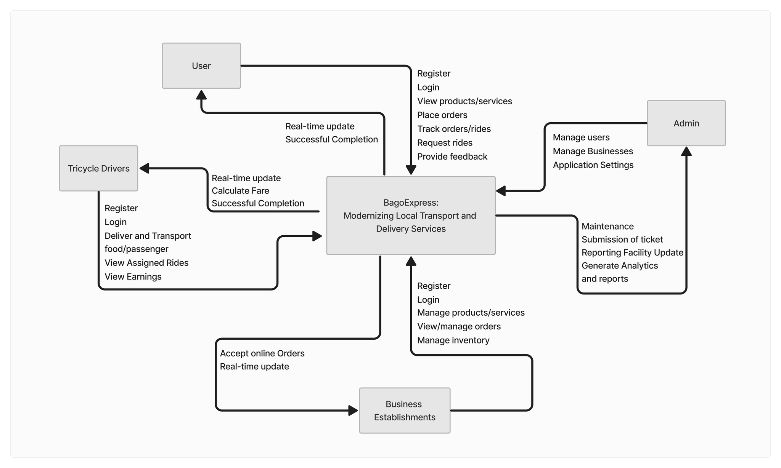 **Context Flow Diagram**

Figure 2. Context Flow Diagram

The context flow diagram shown above represents how the system’s different users interact with one another.

**Design Plan & Software Development**

In this study, it demonstrates the research methodology in a detailed manner, identifying the model base and the model phase. Integration of agile methodology in the model base as a part of the model base, stressing its flexibility, speed and adaptability. It ponders on the core principles of agility, the necessity of the research in meeting the research objectives. Instead of the model phase, chapter by chapter transition is used, from the concept to the real-life application, the article explains how agile principles are put into practice in data management collection, sampling, and analysis. About Software Life Cycle Model, Agile Scrum Model is employed to further support the development cycle.

The Agile Scrum model was consisting of 6 phases or events that repeat in every Sprint: Product Backlog Creation and Refinement, Sprint Planning, Daily Stand Ups, Sprint Review, Sprint Retrospective and Increment. Each Sprint is a cycle, and these phases repeat with every Sprint to ensure continuous delivery and improvement of the product. This model named the “Agile Scrum Model” because of its emphasis on teamwork and collaboration.

**The Phases of Agile Scrum Model**

**Phase One (I). Product Backlog Creation and Refinement**

During this phase for BagoExpress, the Scrum Team (developers, designers, and key stakeholders) works together to prioritize and clarify tasks. Key features include real-time GPS tracking, AI-driven route optimization, secure Gcash payments, and safety reporting. The team breaks down these tasks into smaller, manageable units, ensuring that the requirements are clear and that effort is accurately estimated. Continuous refinement allows for adjustments based on feedback, ensuring BagoExpress meets the needs of Bago City's residents and drivers.

**Phase Two (II). Sprint Planning**

During Sprint Planning for BagoExpress, the team turns prioritized backlog items into tasks for the sprint. The sprint goal is defined, and tasks focus on key needs like better routing, fair pricing, safety features, and online payments. Tasks are broken down, estimated, and team discussions help identify any challenges. This ensures the project stays aligned with goals and stakeholder expectations.

**Phase Three (III). Daily Stand – ups**

“During this phase, daily Stand-ups are brief, daily meetings designed to keep the team aligned and on track. Each team member shares what they accomplished the previous day, outlines their focus for today, and highlights any obstacles they’re facing. Led by the Scrum Master, these meetings are quick and focused, ensuring that everyone remains informed and any issues are addressed promptly. This regular touchpoint helps maintain team cohesion, fosters collaboration, and allows for swift adjustments, which is crucial for effectively meeting our sprint goals and adapting to the evolving needs of the project.”

**Phase Four (IV). Sprint Review**

The Sprint Review is a meeting at the end of each sprint where we show stakeholders what we’ve built. We demonstrate new features like real-time location tracking and payment integration, and get their feedback. This helps us ensure BagoExpress meets user needs and allows us to adjust our plans based on their input. The review also includes discussions to answer questions and make sure everyone understands the project’s progress.

**Phase Five (V). Sprint Retrospective**

The Sprint Retrospective is a key meeting at the end of each sprint for team reflection and improvement. During this session, the team reviews what went well and celebrates successes. They also discuss challenges and obstacles faced, aiming to identify and address any issues that affected progress or morale. This open discussion helps uncover root causes and generate ideas for improvements. The Scrum Master facilitates the meeting and ensures that actionable changes are agreed upon for future sprints. This phase promotes accountability and continuous improvement, helping us enhance the development process and deliver a better BagoExpress system.

**Phase Six (VI). Increment**

The Increment phase is where we see the results of each sprint’s work. With every Increment, BagoExpress grows and improves by adding new features that meet user needs and boost efficiency. Each new Increment builds on previous ones, enhancing the system’s overall functionality. This phase reflects the teamwork and guidance of the Scrum Master and shows our commitment to providing value and responding to feedback. By regularly delivering functional increments, we ensure continuous progress and adaptation to changing requirements. Each Increment marks a step forward in developing a modern and effective BagoExpress system that serves the needs of Bago City’s residents, commuters, and tricycle drivers.

**Architectural Design**

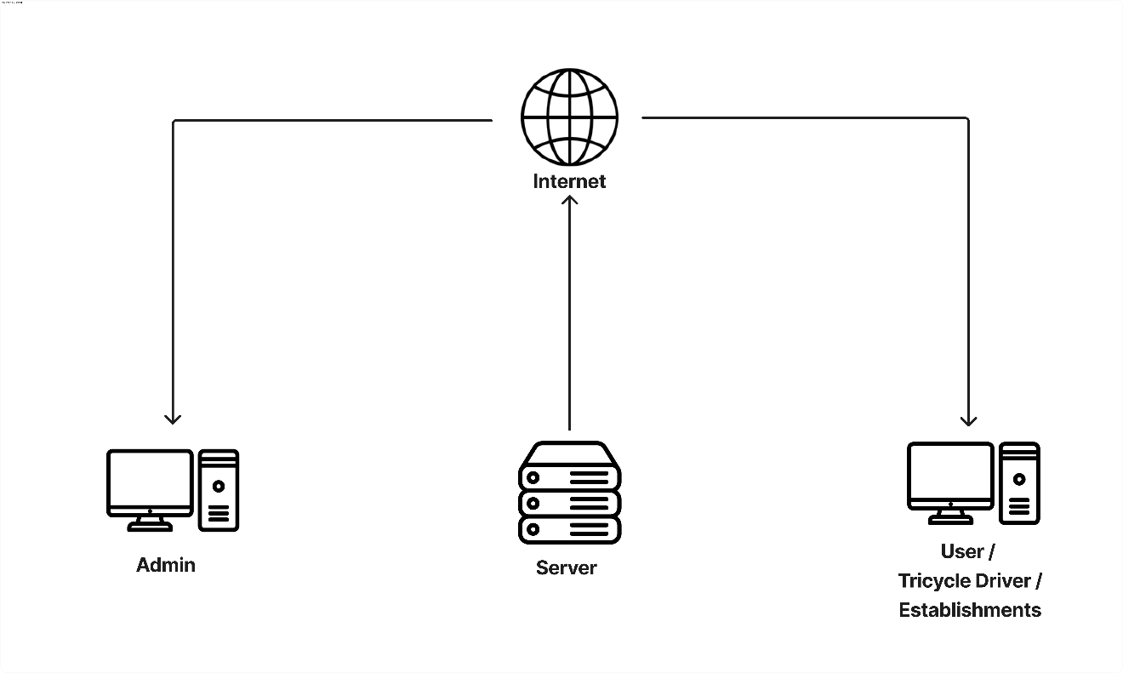

Figure 3. Architectural Design

**Validity And Reliability of the Research Instrument**

The evaluation tool used in our system was made based on a specific study objective and validated with the use of the Good and Scates validation instrument. With a high rating for both content and construct validity, the tool effectively measures key performance indicators such as operational efficiency, customer satisfaction, and service quality, ensuring that the data collected is reliable and actionable for continuous improvement in our delivery and transport services

Table 1. Good and Scates

|  |  |  |  |  |  |  |  |  |
| --- | --- | --- | --- | --- | --- | --- | --- | --- |
| **Number Code** | **Description** | | **Scale** | **Verbal Interpretation** | | | | |
| 5 | Strongly Agree | | 4.22-5.00 | Very High | | | | |
| 4 | Agree | | 3.41-4.21 | High | | | | |
| 3 | Undecided | | 2.60-3.39 | Moderate | | | | |
| 2 | Disagree | | 1.80-2.59 | Low | | | | |
| 1 | Strong Disagree  Table 2. Instrument Evaluation and Validity Criteria | | 1.00-1.79 | Very Low | | | | |
|  |  |  |  |  |  |  |  |  | |
| **Criteria** | | | | **5** | **4** | **3** | **2** | **1** | |
| 1 | The item in the instrument is relevant to answer the objectives of the study. | | |  |  |  |  |  | |
| 2 | The items in the instrument can obtain the depth to the constructs being measured. | | |  |  |  |  |  | |
| 3 | The instrument has an appropriate sample of items for the construct being measured | | |  |  |  |  |  | |
| 4 | The items and their alternatives are either too narrow or limited in their content | | |  |  |  |  |  | |
| 5 | The items in the instrument are stated clearly. | | |  |  |  |  |  | |
| 6 | The items on the instrument can elicit responses that are stable, definite, consistent, and not conflicting. | | |  |  |  |  |  | |
| 7 | The terms adopted in the scale are culturally appropriate | | |  |  |  |  |  | |
| 8 | The layout or format of an instrument is technically sound. | | |  |  |  |  |  | |
| 9 | The responses on the scale show a reasonable range of variation | | |  |  |  |  |  | |
| 10 | The instrument is not too short or long enough that the participant will be able to answer it within a given time. | | |  |  |  |  |  | |
| 11 | The instrument is interesting such that participants will be induced to respond to it and accomplished it fully. | | |  |  |  |  |  | |
| 12 | The instrument as a whole could answer the basic purpose for which it is designed. | | |  |  |  |  |  | |
| 13 | The instrument is culturally acceptable when administered in the local setting. | | |  |  |  |  |  | |

**Reliability of the Test**

Table 3. Expert Validation Result

|  |  |  |  |  |
| --- | --- | --- | --- | --- |
| CRITERIA | EXPERT  1 | EXPERT  2 | EXPERT  3 | AVERAGE |
| 1. | 5 | 5 | 5 | 5.00 |
| 2. | 4 | 4 | 5 | 4.67 |
| 3. | 4 | 5 | 4 | 4.33 |
| 4. | 5 | 5 | 5 | 5.00 |
| 5. | 5 | 5 | 5 | 5.00 |
| 6. | 5 | 4 | 5 | 4.67 |
| 7. | 5 | 5 | 5 | 5.00 |
| 8. | 5 | 4 | 5 | 4.67 |
| 9. | 4 | 5 | 4 | 4.33 |
| 10. | 5 | 5 | 5 | 5.00 |
| 11. | 5 | 5 | 5 | 5.00 |
| 12. | 4 | 4 | 5 | 4.33 |
| 13. | 5 | 5 | 5 | 5.00 |
| TOTAL |  |  |  |  |
| AVERAGE | 4.69 | 4.77 | 4.92 | 4.79 |

A reliability test was performed using Del Siegle's reliability calculator, resulting in a Cronbach's Alpha value of 0.71. This indicates that the instrument demonstrates acceptable internal consistency, confirming its reliability for measuring the intended variables.

**Results**

Table 4. Mean and Standard Deviation

|  |  |  |  |  |
| --- | --- | --- | --- | --- |
| Objective | Mean | Standard Deviation | Description | Interpretation |
| 1 | 4 | 0 | VS | The system meets all user interface and experience goals. |
| 2 | 3.80 | 0.42 | VS | The system effectively determines routes with high accuracy. |
| 3 | 3.75 | 0.39 | VS | The system meets objectives for real-time driver tracking. |
| 4 | 3.85 | 0.36 | VS | The system offers a reliable and efficient payment system. |
| 5 | 4.00 | 0 | VS | The system performs consistently without errors or failures. |
| 6 | 3.90 | 0.30 | VS | The system brings innovative solutions to local transport. |
| Overall Mean | 3.88 | 0.25 | VS | The system has successfully met the objectives of the study. |

Legends: VS – Very Satisfied

As presented in Table 4, the overall mean of 3.8 reflects that the developed system has successfully achieved its specific objectives. This result comes from a survey conducted using purposive sampling with 15 respondents. A mean score of 3.8 corresponds to a "Very Satisfied" (VS) rating, which falls within the 3.25–4.00 range.

Table 5. Experts Evaluation based on ISO/IEC 25010:2011

|  |  |  |  |
| --- | --- | --- | --- |
| **Software Characteristics** | **Mean** | **Description** | **Interpretation** |
| Functional Suitability | **4.45** | **VG** | The system effectively supports real-time GPS tracking, AI-driven route optimization, and secure online payments, meeting most quality standards with minor improvements needed. |
| Performance Efficiency | **3.85** | **VG** | The system performs well, but some optimization is required during peak traffic and delivery periods to maintain high responsiveness. |
| Compatibility | **4.10** | **VG** | The system operates smoothly across multiple devices and platforms. Minimal adjustments are necessary to enhance performance on older devices. |
| Usability | **4.25** | **VG** | Users find the system highly user-friendly, with clear navigation and efficient processes. Very few modifications are required. |
| Reliability | **3.95** | **VG** | The system is stable and performs reliably under various conditions, though improvements could ensure even greater consistency during peak times. |
| Security | **4.50** | **VG** | The system offers robust security features for payments and data protection, with no adjustments necessary. |
| Maintainability | **4.30** | **VG** | The system is easy to maintain and update, allowing for smooth software upgrades and troubleshooting. |
| Portability | **4.15** | **VG** | The system can be transferred or adapted across different platforms and devices with minimal effort. |
| **Over-all Mean** | **4.19** | **VG** | The system meets almost all software development quality standards with very slight adjustments needed in specific areas. |

Legends: VG – Very Good

In accordance with the ISO/IEC 25010:2011 standard, the system met all the prescribed software quality criteria. The overall mean score, as rated by IT experts and professionals, is 3.56. This falls within the 3.25–4.00 range, corresponding to a rating of 'Very Good (VG).

**Summary of Findings**

1. The BagoExpress system has successfully modernized local transport and delivery services by integrating AI-powered route optimization, real-time GPS tracking, and cashless payment solutions, ensuring efficient and reliable service.
2. The system provides enhanced safety features, such as real-time location sharing during nighttime rides and monitoring via GPS, which has significantly improved the safety and peace of mind for passengers and their trusted contacts.
3. Business owners and tricycle drivers now benefit from AI-driven "Smart Routing," which optimizes travel routes, reduces fuel consumption, and ensures adherence to fair pricing, leading to increased operational efficiency.
4. The cashless payment system, integrated with GCash, has been widely accepted, simplifying transactions and reducing the risks associated with carrying cash, while ensuring secure and convenient payments for passengers and drivers alike.
5. Users expressed high levels of satisfaction with the system’s user interface, ease of use, and consistency, highlighting BagoExpress's success in addressing the transport and delivery needs of the local community.

**Conclusions**

The BagoExpress system successfully modernizes local transport and delivery services in Bago City, improving safety, efficiency, and convenience for both passengers and drivers. Key features such as AI-powered route optimization, real-time GPS tracking, and cashless payments have addressed critical challenges in traditional transport. While the system has met its objectives, future enhancements in scalability and performance, especially during peak hours, could further optimize the user experience. Overall, *BagoExpress* marks a significant advancement in modernizing and streamlining local transport services, paving the way for future growth and innovation.

**Conflict of Interest.** The authors declare that for this article they have no actual, potential or perceived conflict of interests.

**References**

1. Conal Mcguirk: Transforming Local Transport and Delivery Systems

<https://weareconker.com/blog/ways-technology-is-changing-the-delivery-and-courier->

industry/

1. Meng Xu, Guenter Emberger: Innovation in Urban Transportation: The Role of Modernized Delivery Systems

<https://www.sciencedirect.com/science/article/abs/pii/S2210539521000183>

1. Ata Khan, Rhen Thomas: Leveraging Technology for Efficient Local Transport Services

<https://irpp.org/research-studies/leveraging-digital-technologies-for-public-transportation/>

1. Dr. Jean Paul Rodrigue and Dr. Theo Notteboom: The Socio-economic Impact of Technology-Driven Transport Solutions

<https://transportgeography.org/contents/chapter3/transportation-and-economic-development/>